Real Action Gaming Robots RAGOBOTS

Hardware Design Overview



Jonathan Friedman, GSR
Lead Project Hardware Engineer

Networked Embedded Systems Laboratory (NESL)
University of California, Los Angeles (UCLA)

Ragobot Features
Power
Integrated Battery Charging and Monitoring
Integrated Regulated Power Supply
Circuit Power Protection
Independent Processor Shutdown Control of Power Consuming Devices (default to on)
Energy Efficient, Low-noise Design
Sensing
3D Orientation Sensing
IR Distance Sensor
8 LED’s for output and status
Actuation
Dual motors with high resolution speed controller
Gripper unit
Pan/tilt mount for positioning sensors
Programming
Integrated programming board
Onboard UISP interface (download TinyOS code to Ragobot without removing mote)
Onboard JTAG interface
Expansion
Power headers
Mica2 pins are pulled to header for expansion modules (and probing)
Ease of Assembly
Avoid use of extremely small surface-mount components, unless unavoidable
Accurate silk-screen documentation

CONVENTIONS

Always put off-page connectors on right side of schematic
Minimize the use of net labels for connectivity (use for nominating only)
Symbols should bear resemblance to the likeness of the actual part

POWER

Power Supply (Overview):
5V regulated output (powers the onboard cpu and peripherals)
1A or better

3.3V regulated output (powers the mote)
300mA or better

8.4VDC → 5.5VDC battery input
Design to use whole range

Reject linear regulator because:
- Inefficient (efficiency ~70%)
- Dropout is too great
- Example: LM2940-5 (59%-->91%, linear, simple)

Reject LDO regulator because:
- Inefficient
- Dropout is still too great (can only tolerate 0.5VDC)

Reject integrated switching regulators because:
- Inefficient
- Example: LM2592-5 (77% efficiency, switched, simple to use)

Fuses unnecessary due to internal current limiting on regulator parts

Integrated Battery Charger:
Total input current (when charging) limited to 3.75A, nominal
Battery charge voltage is 4.2V x 2 (b/c of 2 cells in series)
Reference output on MAX1908 is not bypassed to ground (why bother?) – possible float on current limit ~3.75A +/- noise. Safety margin should absorb this limit flux without problem.
NO THERMAL LIMITING is provided in the case of the battery overheating. There is no temperature sensor available to monitor the battery.

Power Control:
onboard CPU is always on (unless local software commands sleep mode)
Sensors have common power (and control) – attitude, Gripper ID, IR Ranger
Battery monitor is always on
Shutdown of battery charger (digital)
All Servo’s through common power switch
Power to Aux board (high current, low Rds,on path)

Motors are powered by the same regulator as the logic and sensors. To eliminate the large voltage fluctuations on the regulated output to the processor and analog sensors caused by frequency modulating the 500mA engine load, large step-in (line-regulation) capacitors are provided.

The mote is powered by a separate 3.3V synchronous regulated supply. CPU shutdown of this regulator is provided, but probably unnecessary. Simply holding the mote in reset will reduce its power consumption to the level that the regulator will automatically go to sleep.

Power Supply Module Signal Descriptions:
Battery – input, from the rover base
Charge – input, from the rover base (the contact rails to the energy recharge building)
At_base – output, active low, logic low when receiving at least 2V from an external source (presumably the recharge base building in the game)
Bc_Shutdown – enables/disables the battery charging circuit

Battery Monitor:
Temperature measurements from the unit will be useless for battery issues, but they measure ambient temperature about the robot so perhaps that is of interest. Uncommitted ADC channel monitors the current coming in from the external charging circuit (AC adapter or Charging Station).
Bm_Rsens is 0.025 ohms which leads to a +/-5A current range

Ground Plane Design:
The sensitive analog instruments are protected by their own analog ground plane. The problem comes from the fact that the mote (and thus the ADC input) are located on a digital (noisy) plane. The mote’s onboard isolation circuitry is ineffective because we are providing power back through the expansion connector (and not the onboard battery), bypassing the protective elements. The mote’s analog ground plane is not wired to header. Therefore, it is impossible to travel the ADC inputs over analog ground planes exclusively. We could minimize current loop areas by attaching both the Ragobot’s ground planes (analog and digital) to the mote connector, but this would lead to vastly effective ground loop currents. Given that minimal loop area is not really achievable anyway (because of the lack of analog ground exposure on the header) and that attempting to minimize the area compromises the isolation of the analog plane it is decided that the analog ground plane will not attach to the mote header. This approach maintains the noise rejection of the analog planes while traveling the analog inputs over digital planes for as brief a distance as possible. This should produce the best possible analog signal quality at the mote ADC inputs.

Ground Plane Interconnection Design:
The so-called zero-ohm resistors are etched directly on the PCB and were shaped using Brad Suppanz model based on curves fit to IPC-D-275. The calculations are derived from a paper titled "Temperature Rise in PCB Traces" by Douglas Brooks, UltraCAD Design, Inc.

The interconnections are 5A tolerant at room temperature for an internal layer at an acceptable level of 10 deg C thermal rise in 1-oz copper clad board. The length of the interconnect is 100mil. This results in a 350mil wide interconnect.

Noise Injection Analysis
Noise injection in our design comes from three principal sources. The voltage regulators are synchronous with a fundamental frequency of 90kHz. The radio on the mote operates around 433MHz. Finally, the battery charger (when active) injects noise at a maximum 3.5 Mhz. As a minor consideration, the mote oscillators operate at 7.3728MHz and 32kHz. Clearly filtering these sources is no small task given the wide bandwidth formed by these disparate fundamentals and their harmonics.
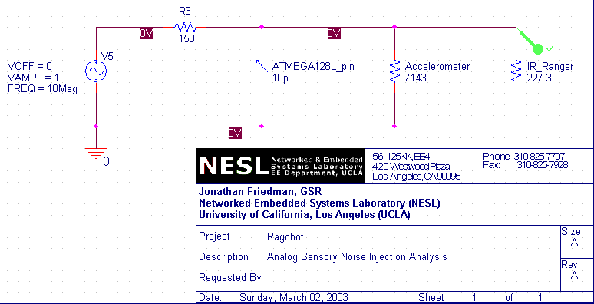

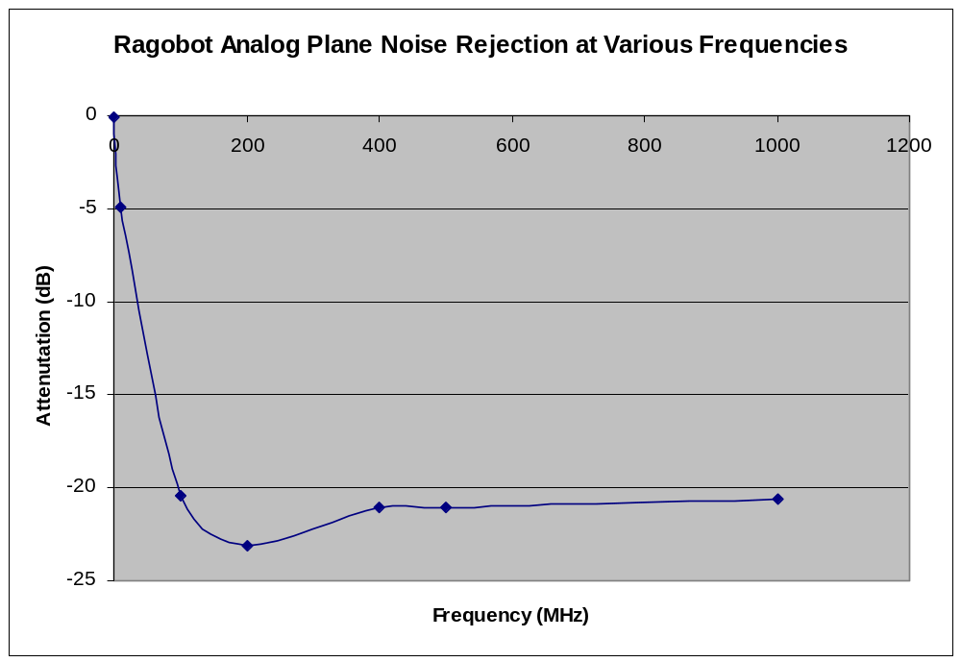
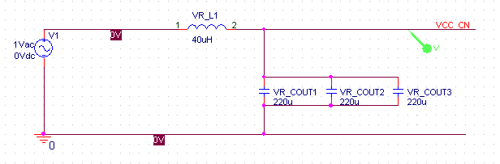
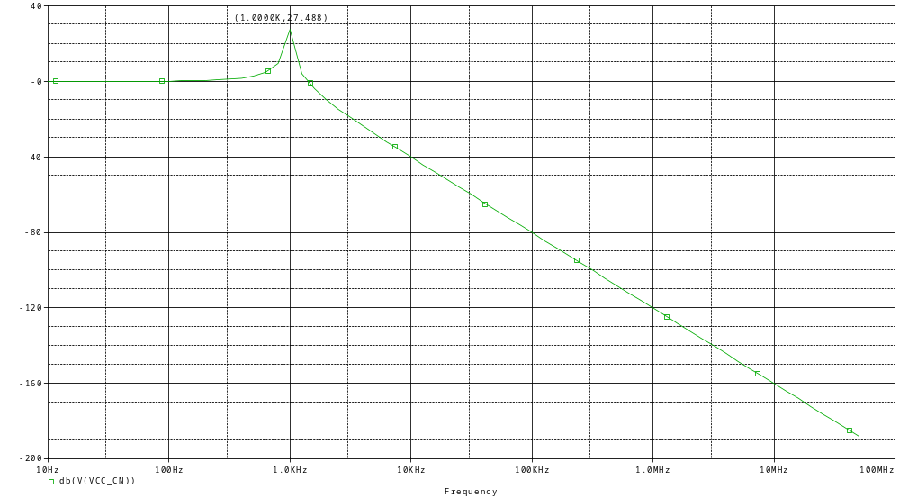
The output filter on the power supply provides excellent suppression at the PWM frequency (90kHz and its upper harmonics). The tradeoff is that it acts as a noise amplifier at around 1kHz with a gain of 27dB. This band is later filtered out by an RLC second-order highpass.

AC Power Inverter
Maximum DC input is 16V. Minimum is (12?, look this up, limited by min required to clear charger). 12v limit input to battery monitor.

The circuit is well protected against undervoltage, but offers no direct notification to the processor in this event. Detecting an input bus undervolt condition requires checking the adapter input current statistic handled by the DS2438 (use the 1-wire bus to issue the appropriate request for data). During undervolt, current will be zero (or very low). The At_Base signal may be disasserted during undervolt (or may otherwise become unreliable).

Only minimal protection is provided against the overvoltage condition. Exceeding the upper limit for extended periods will cause the output filter capacitors to fail. DC inputs over 25V will permanently damage the charging circuitry.

Power Output Limitations
The 3V and 5V rails can source up to 1.2A continuously before the feedback inductors will fail.

The Pwr_Supply_1 loop (auxiliary sensor power plane) can handle a maximum of 300mA before the isolation bead fails.

SENSING

Attitude Sensor:
Actual sensor is a dual-axis accelerometer. It is low-pass filtered to a bandwidth of 10Hz.

Gripper Sensors:
The gripper is instrumented with two sensors. The digital sensor generates a mote interrupt on object detection (falling edge). The analog sensor reads SENSOR_VCC_CN and drops according to the resistance embedded in the object – hence identifying it. Nominal pullup is provided onboard the Mica2 at 10KOhms. In order to use the analog sensor M2_THERM_PWR must be setup as an input (high-Z, no internal pullup).

ACTUATION

Motor Control & Flash Memory:
The motor controller and Mica2 external flash memory chip share the mote’s UART1 TX line (RX is dedicated to the Flash chip). This does not cause problems if you are careful. To use the flash chip, hold the motor controller’s reset line in (or ensure that you do not send the address byte so that the motor controller will ignore the data). To use the motor control deassert the Flash memory’s chip select line.

Motor Control & Noise Injection:
The motor controller is powered from VCC_CN (digital power plane). This was done to minimize its impact on the more noise sensitive circuits. The digital power plane is already noisy. Drops in voltage output

LED’s:
1 tri-color LED at each corner for “team” identification. B/c these are designed to be always on, I’ve used a low current LED (not particularly bright).
Blue super bright LED on turret
8 Burning LED’s (6 above, 2 below)
G,Y,R multicolor 10-segment bar graph display

PROGRAMMING

JTAG:
Option to power JTAG from the Ragobot is not provided
JTAG inputs are not filtered. It is assumed that JTAG will not be present when the application is in its actual run state, so we tolerate noise from JTAG in exchange for 8 fewer PCB components.

EXPANSION

CB2:
See page 15-6 in Peatman’s book for timing and control diagram

SOFTWARE DESIGN NOTES

Be sure to enable internal pullup resistors on pins E5 (M2_INT1: Gripper digital sensor)

OVERALL DESIGN PROCESS

- Finish Layout
- Analyze Power Planes
- Redraw any logic signals to separate planes
- Spec small parts
- Do layout
- Verify layout and connectors

